**Natural Selection and the Peppered Moth**[1]

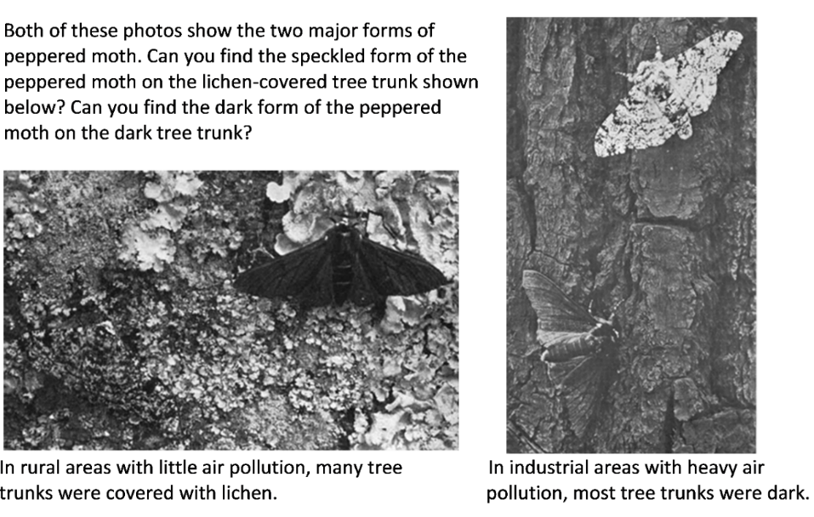

Peppered moths are active at night. During the day, they rest on tree trunks and branches. Some of these resting peppered moths are eaten by birds. Birds use their vision to find their prey. Researchers have found that, in each environment shown above, predation by birds resulted in higher mortality for the moths that had less effective camouflage in that environment.

**1.** In each photo, circle the form of the peppered moth that would be more obvious to bird predators and, as a result, would have higher mortality in that environment.

An individual peppered moth cannot change from speckled to dark or vice versa. The difference between the speckled and dark forms of the peppered moth is inherited. Specifically, this difference results from different alleles of a single gene. The allele for the dark form (**D**) is dominant over the allele for the speckled form (**d**). This means that **Dd** moths are dark.

|  |  |
| --- | --- |
| **2a.** Complete these Punnett squares.  **2b.** Circle the genotype of each parent and offspring that would be dark. |  |

**2c.** Explain why the offspring of peppered moths generally look like their parents.

**3.** Because the speckled vs. dark forms are genetically determined, individual moths cannot adapt to changes in their environment. However, populations of moths can adapt to changes in their environment through evolution by natural selection. The left column of this table lists two requirements for natural selection to occur. Complete this table to give evidence that the peppered moth example fulfills each of these conditions.

|  |  |
| --- | --- |
| Requirements for Natural Selection  to Occur | What is the evidence that the speckled vs. dark forms of the peppered  moth fulfill each necessary condition for natural selection? |
| Differences in the characteristic must result in differences in fitness. (Fitness is the ability to survive and reproduce in an environment.) |  |
| Differences in the characteristic must be inherited. |  |

**4**. Complete this table to describe the expected effects of natural selection as the environment changed in regions of England that became industrialized.

|  |  |  |
| --- | --- | --- |
| History of Environmental Change in Industrial Regions of England | Expected Effects of  Natural Selection on  % Dark Peppered Moths | Expected Trends in % **D** Alleles  (for the **D**/**d** gene that determines the dark vs. speckled form) |
| Before 1850, air pollution was low and tree trunks and branches were lighter and often covered with lichen. | The dark form of the peppered moth was more likely to be eaten by birds, so the dark form had low fitness and was very rare. | Moths which have a **D** allele are dark. In this environment, dark moths rarely survived to reproduce. Therefore, the **D** allele was very rare. |
| After ~1850, industrialization resulted in air polluted with soot; the soot darkened tree trunks and branches. | Decrease ___  Increase ___  Stay the same ___ | Decrease ___  Increase ___  Stay the same ___ |
| After ~1960, government regulation resulted in reduced air pollution, so tree trunks and branches became lighter. | Decrease ___  Increase ___  Stay the same ___ | Decrease ___  Increase ___  Stay the same ___ |

|  |  |
| --- | --- |
| These graphs show trends in the percent dark peppered moths and the percent **D** alleles in an industrial region in England. Each dot in the upper graph represents a data point. The lines show the estimated trends; the width of each line indicates the uncertainty in the estimates.  **5a**. Do these graphs support your predictions in question 4?  yes ___ partly ___ no ___  **5b.** Explain the causes of any trends that are different from your predictions. |  |

**6.** A student wrote this paragraph to explain the causes of the trends in the top graph click save as.

During industrialization, air pollution resulted in dark tree trunks and branches. Most of the peppered moths became dark, because the peppered moths needed to be dark so they would not be seen and eaten by birds. Then, air pollution decreased, so tree trunks and branches became lighter, so the peppered moths needed to become speckled so they would not be eaten by birds.

Write a scientifically more accurate explanation of what happened to cause the trends in the top graph. (A complete answer will include natural selection.)

|  |  |
| --- | --- |
| **7.** In this graph, predict the trend in the percent of peppered moths that were dark in non-industrial rural regions. Explain your reasoning. |  |

|  |  |
| --- | --- |
| Similar trends were observed in industrial regions in England and the US. After ~1960, air pollution decreased and the percent of peppered moths that were dark decreased.  In non-industrial rural regions, air pollution remained low and dark peppered moths were rare throughout this time period. |  |

**8a.** Was natural selection occurring in the rural regions? yes ___ no ___

**8b.** Explain your reasoning.

Scientists have observed multiple additional examples of natural selection in action. For example, natural selection has increased antibiotic resistance in many types of bacteria, and natural selection has increased resistance to pesticides in many types of insects.

**9a.** Many people think of the process of evolution as "survival of the fittest". How do you think most people interpret "survival of the fittest"?

**9b**. Biologists define fitness as the ability to survive and reproduce in an environment.What are some characteristics that can contribute to fitness?

**10.** Explain how the peppered moth example illustrates the following general principles.

**A**. Natural selection acts on individuals, but only populations evolve.

**B**. Natural selection acts on phenotypes, but natural selection results in changes in allele frequencies. (Phenotypes are the observable characteristics of organisms.)

1. By Dr. Ingrid Waldron, Dept Biology, University of Pennsylvania. © 2025. A Word file and Teacher Preparation Notes with instructional suggestions and biology background are available at <https://serendipstudio.org/exchange/bioactivities/NaturalSelectionMoth>.